Assignment 19 Feb 2019 : Introduction to Java 1

Q1. Write a program to replace a substring inside a string with other string ?

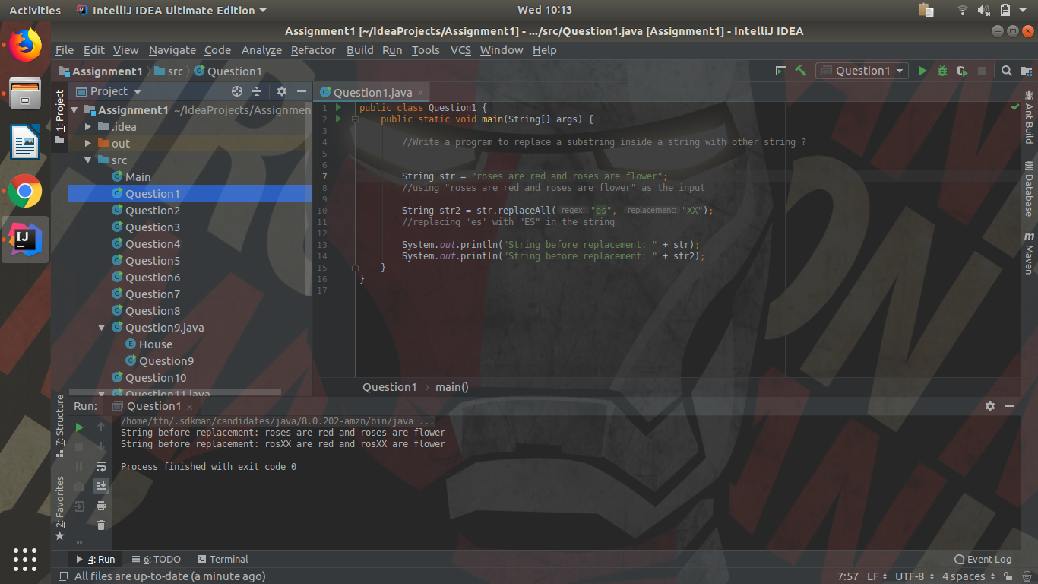
Java File: Question1.java

Q2. Write a program to find the number of occurrences of the duplicate words in a string and print them ?

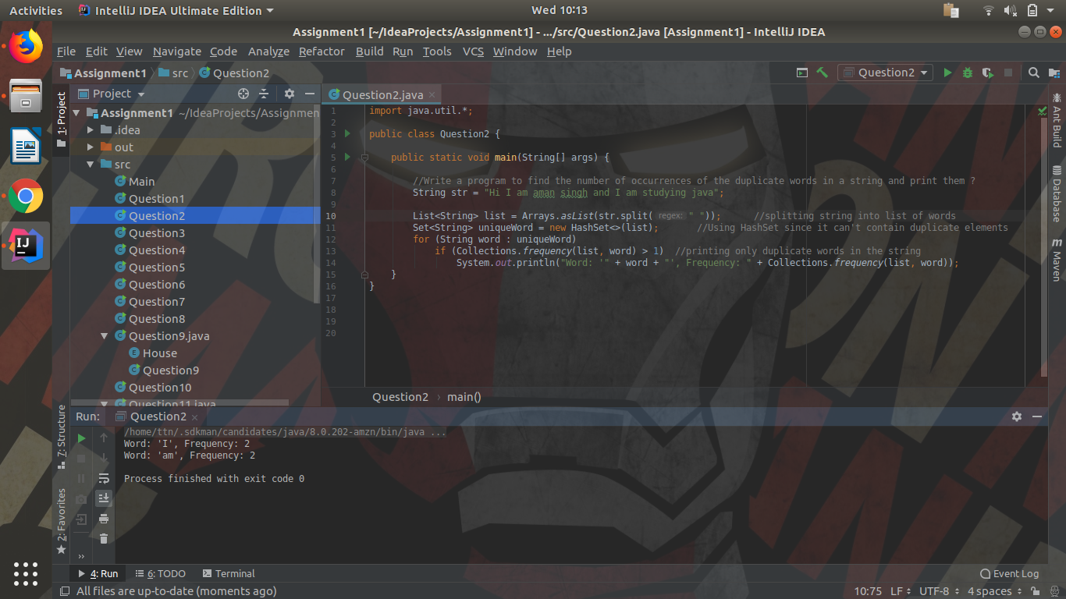
Java File: Question2.java

Q3. Write a program to find the number of occurrences of a character in a string without using loop?

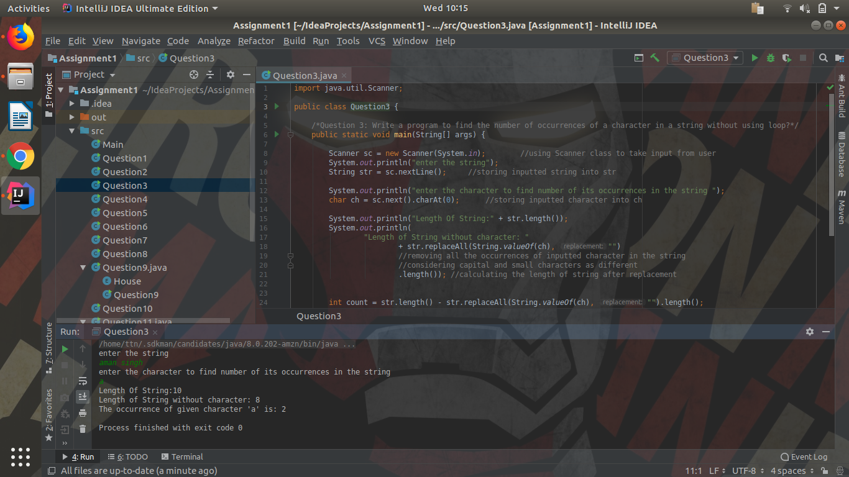
Java File: Question3.java

Q4. Calculate the number & Percentage Of Lowercase Letters,Uppercase Letters, Digits And Other Special Characters In A String

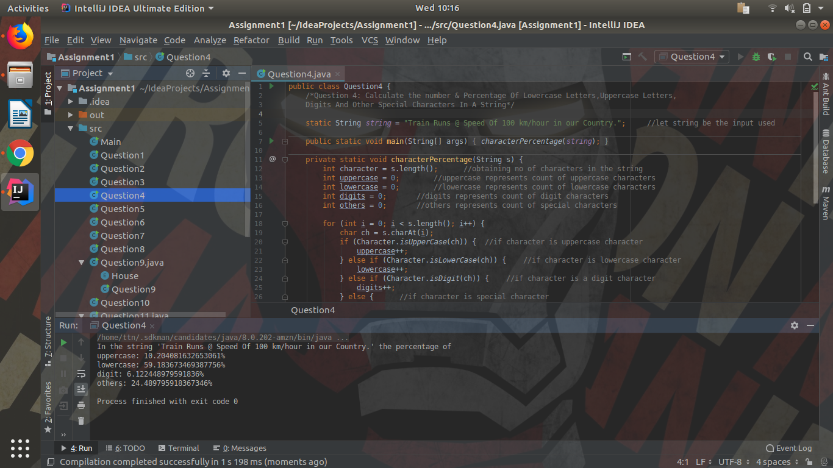
Java File: Question4.java

Q5. Find common elements between two arrays.

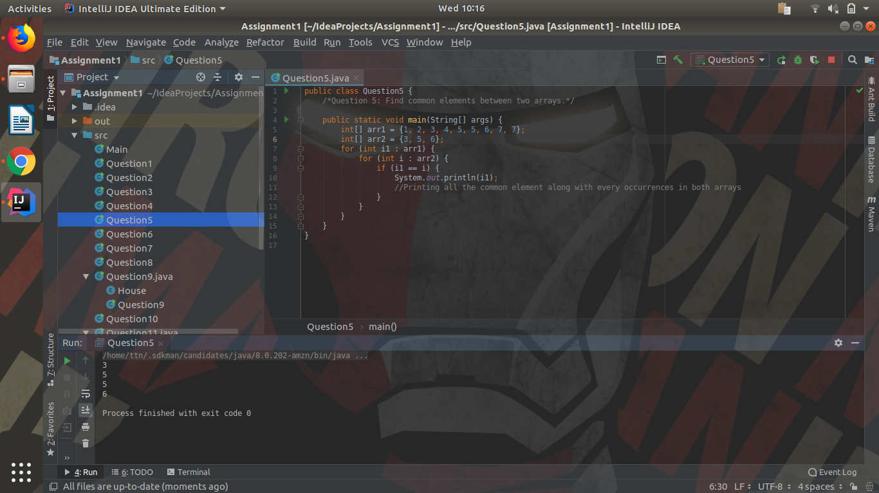
Java File: Question5.java

Q6. There is an array with every element repeated twice except one. Find that element

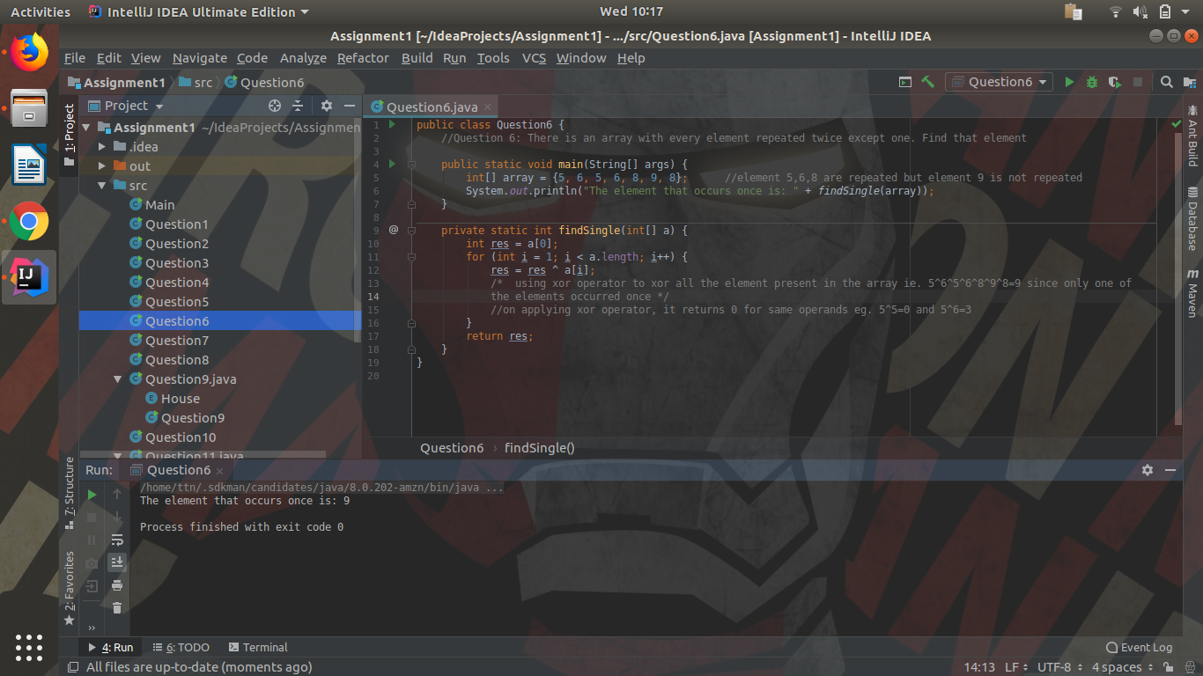
Java File: Question6.java

Q7. Write a program to print your Firstname,LastName & age using static block,static method & static variable respectively

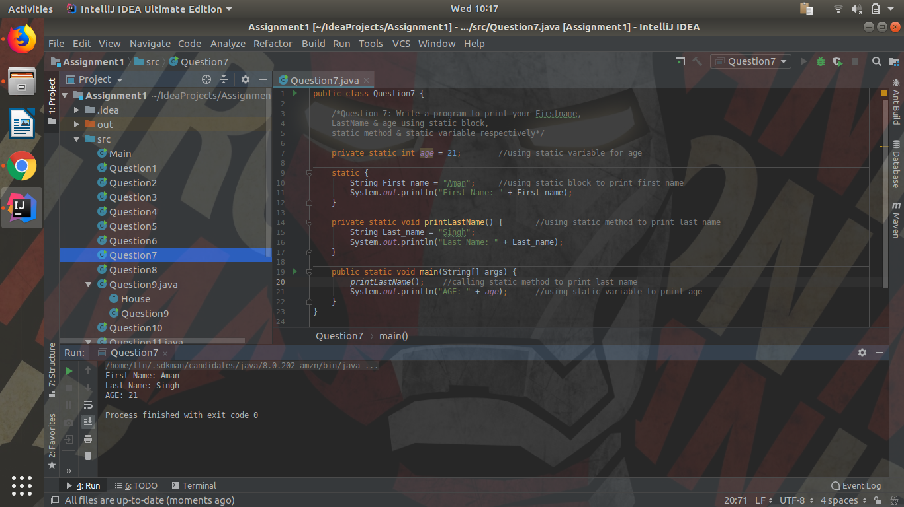
Java File: Question7.java

Q8. Write a program to reverse a string and remove character from index 4 to index 9 from the reversed string using String Buffer

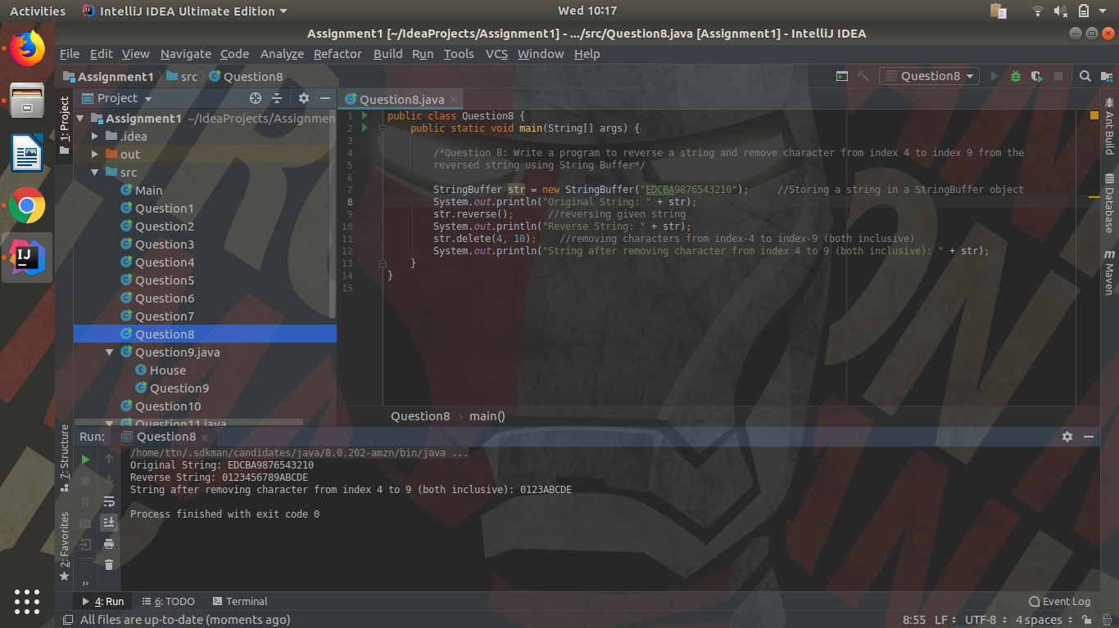
Java File: Question8.java

Q9.Write a program to display values of enums using a constructor & getPrice() method (Example display house & their prices)

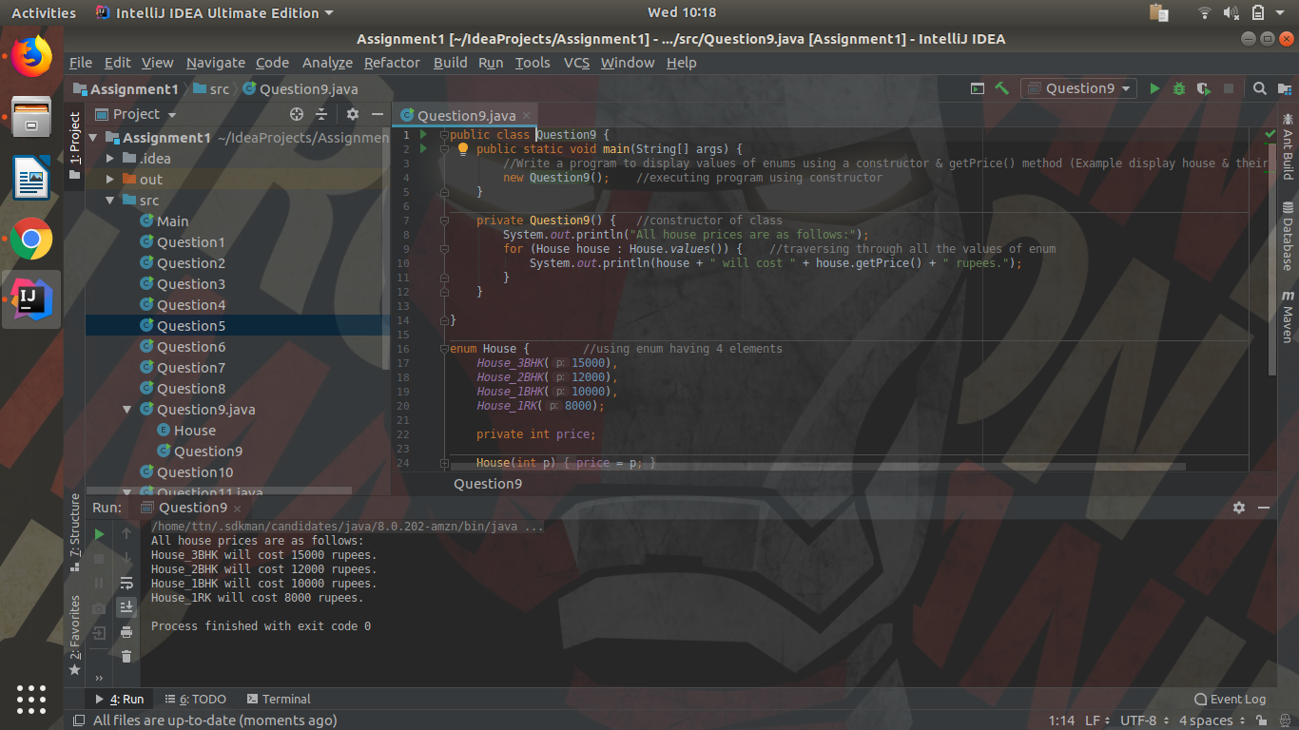
Java File: Question9.java

Q10.Write a single program for following operation using overloading
A) Adding 2 integer number
B) Adding 2 double
C) multiplying 2 float
D) multiplying 2 int
E) concate 2 string
F) Concate 3 String

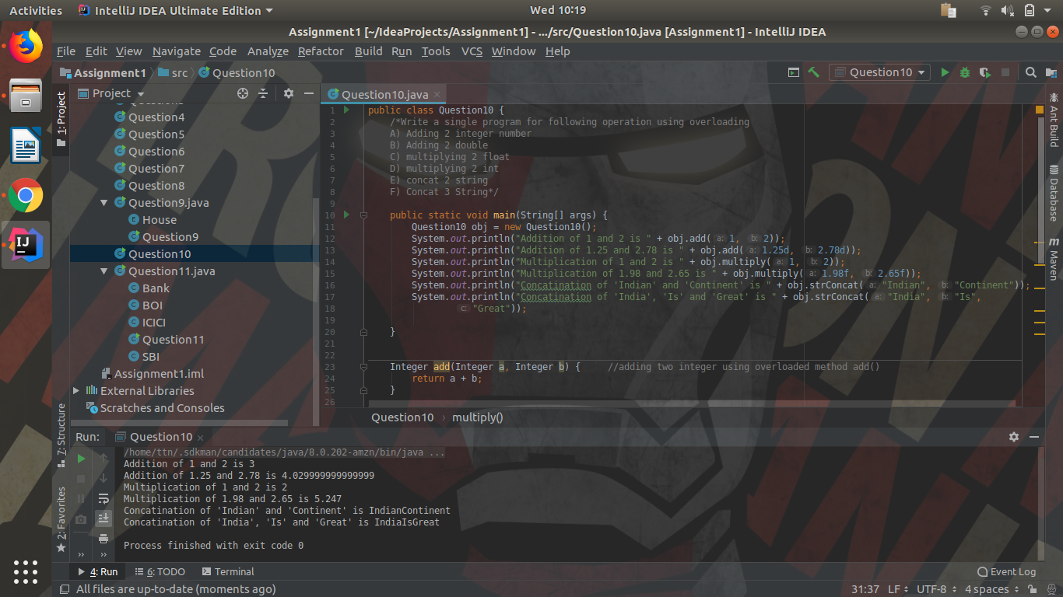
Java File: Question10.java

Q11.Create 3 sub class of bank SBI,BOI,ICICI all 4 should have method called getDetails which provide there specific details like rateofinterest etc,print details of every banks

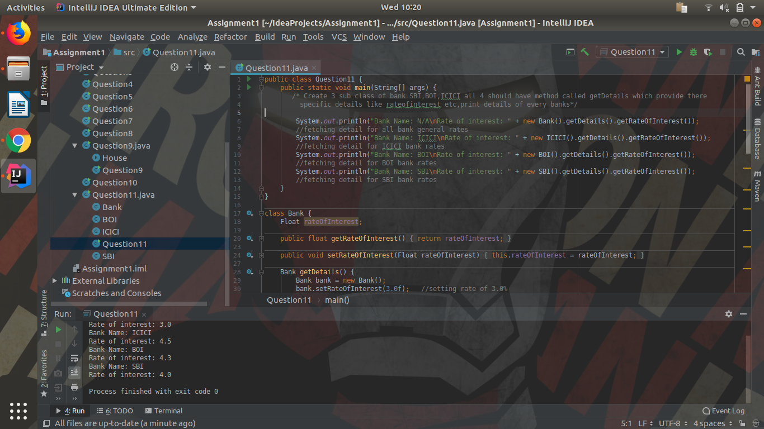
Java File: Question11.java

